***Directions:*** Answer the following questions below to the best of your ability. Submit into BB under practice exam file (5 points each).

**COP2335: Object-Oriented Programming Practice Exam**



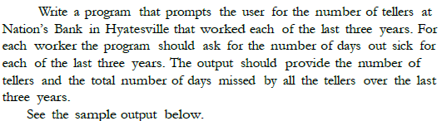

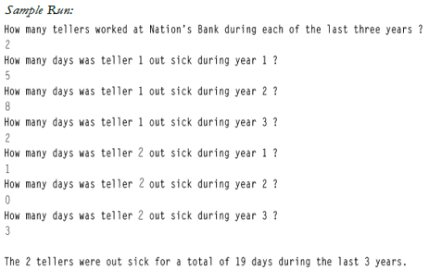

**Snippet of the Code:**

**Snippet of the Output:**



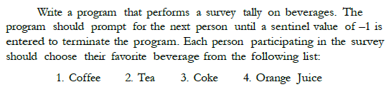

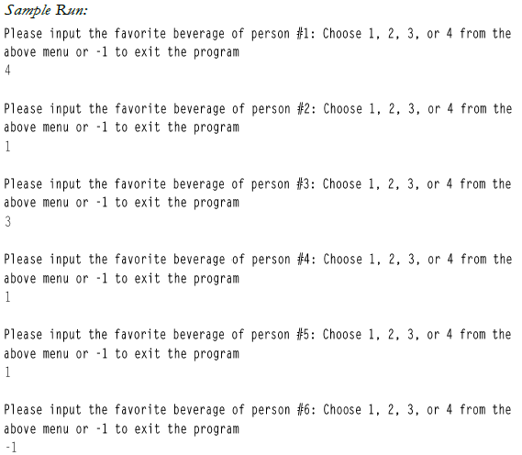

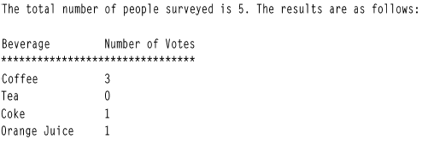

**Snippet of the Code:**

**Snippet of the Output:**



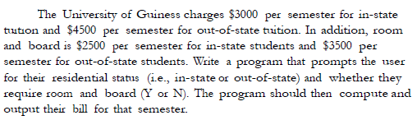

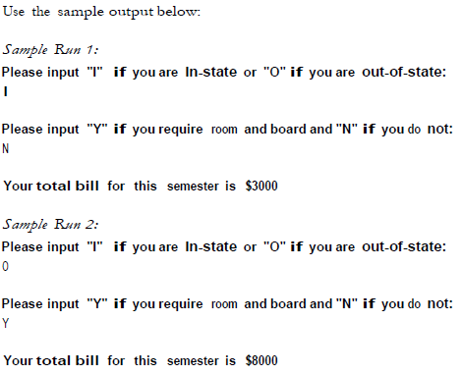

**Snippet of the Code:**

**Snippet of the Output:**



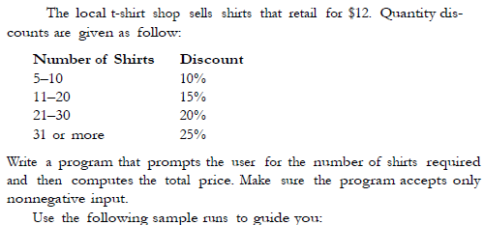



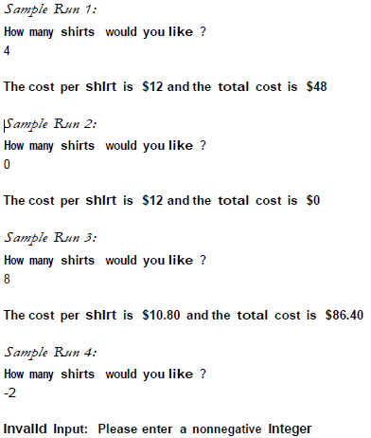

**Snippet of the Code:**

**Snippet of the Output:**



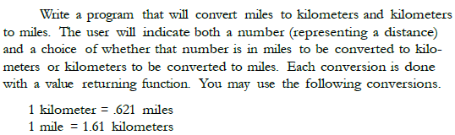



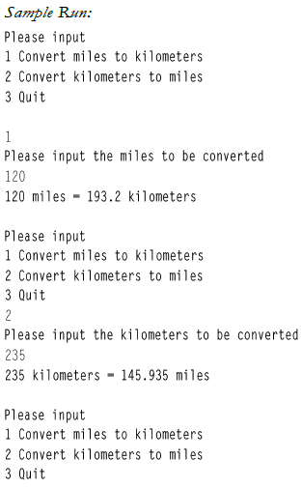

**Snippet of the Code:**

**Snippet of the Output:**

